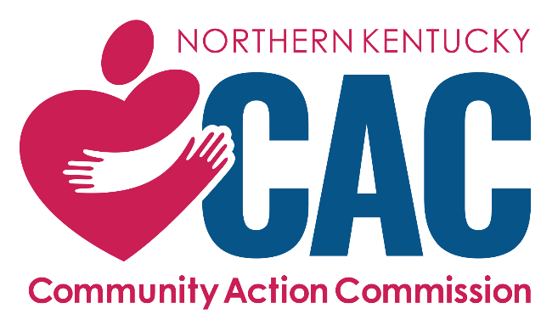

Cleaning Services

Request for Proposal

Vendor Questionnaire

RFP COORDINATOR:

Melissa Willis

Northern Kentucky Community Action Commission
717 Madison Avenue
Covington, KY 41011

mwillis@nkcac.org
859-655-2967

Issued Date: April 18, 2025
DEADLINE: May 23, 2025 at 12:00 p.m.

Vendor Questionnaire

Please provide the following information about your company.
1.0 Company Profile
1.1 | Company Name
1.2 | Company Address
1.3 | Contact Information  (Party responsible for responding to this RFP)
1.4 | Company Webpage (If applicable)
1.5 | Number of years in the Market
1.6 | Company location(s)
1.7 | Number of Employees vs Contractual Staff
INSTRUCTIONS: Vendor must complete all sections of the attached Vendor Questionnaire and submit with a proposal document, pricing breakdown, and a version of any master services agreement or contract that would be utilized if chosen.

If additional material is required for one or more questions, please label attachments clearly and reference them in your response. Responses received that fail to address each of the sections in adequate and complete detail will be deemed as non-responsive and will not be considered for selection. Note that responses of “to be provided upon request” or “to be determined” or the like, or that do not otherwise provide the information requested (e.g., left blank) are not acceptable.

2.0 General
2.1 |  | Q. What is unique and distinguishing about your company?
 |  | A.
2.2 |  | Q. Why do you believe that you are a good fit with our agency?
 |  | A.
2.3 |  | Q. Provide your company’s vision and mission statement, and key services offered (this can include non-cleaning services and/or additional cleaning services not in the scope of the RFP).
 |  | A.
2.4 |  | Q. Has your company visited all the NKCAC locations you hope to service?  If not, why? Which, if any, have you visited?
 |  | A.
2.5 |  | Q. Have you reviewed the attached checklist of required services? NOTE: Submitting a proposal indicates that you agree to use NKCAC’s checklist with each visit.
 |  | A.
2.6 |  | Q. If you plan to offer the yearly/semi-annual deep cleaning option, please provide a complete list of services you will be providing as part of that service.
 |  | A.
2.7 |  | Q. Provide a detailed schedule example for each location to be serviced under this contract. It should describe the number of employees, hours of service, time of arrival, and day(s) per location.
 |  | A.
2.8 |  | Q. Does your company ever contract out services or do you employ all your workers? Please explain.
 |  | A.
2.9 |  | Q. Describe how your workers are trained.
 |  | A.
2.10 |  | Q. What will be the preferred mode of communication between janitorial staff and NKCAC staff?
 |  | A.
2.11 |  | Q. What is your company’s corrective action procedure to ensure that problems are solved quickly and not repeated?
 |  | A.
2.12 |  | Q. Who will be the primary point of contact for emergency responses? Please provide all contact information.
 |  | A.
2.13 |  | Q. Will you be able to support NKCAC’s fundraising efforts? What will that look like?
 |  | A.
2.14 |  | Q. How do you maintain excellent customer service? Please provide examples.
 |  | A.

3.0 Fee Proposal:
Vendors may bid on all facilities, or individual ones that fall in their business area. NKCAC reserves the right to divide cleaning services across multiple vendors to provide services in all counties served. Please mark N/A on any location(s) you are NOT able to provide service.
Location | Address | Square Footage | Required Service Frequency | Planned Service Hours | Vendor Pricing | Deep Cleaning Pricing
Example Location | 123 Smith Street | 1,000 | 1 day a week | 4:30-6:00  Mondays | $XXX per month | $XXX per visit
Central Office | 717 Madison Ave Covington | 13,617 | 2x weekly
533 West Pike | 533 W Pike St  Covington | 3,600 | 2x weekly
Newport Admin | 437 West 9th St  Newport | 8,400 | 2x weekly
Boone CNC | 6616 Dixie Hwy, Suite 200, Florence | 2,968 | 2x weekly
Boone County HS | 3261 Maplewood Drive, Burlington | 15,000 | 5x weekly  Gym 1x weekly
Carroll CNC | 1014 Seminary Street Carrollton | 2,000 | 2x weekly
Eastside Child Development | 1001 Scott Street, Covington | 5,183 | 5x weekly
Elsmere HS | 1021 Capitol Avenue, Elsmere | 8,725 | 5x weekly
Falmouth HS | 409 Barkley Street Falmouth | 2,156 | 2x weekly
Gallatin NC | 100 Davis Drive  Suite 1&2, Warsaw | 1,220 | 2x weekly
Grant CNC | 1116 North Main Street Williamstown | 3,000 | 2x weekly
Newport HS | 502 West 9th Street, Newport | 12,400 | 5x weekly
Owen CNC | 970 US Highway 127 Owenton | 1,623 | Tuesday & Friday
Pendleton CNC & RSVP | 400 Main Street  Falmouth | NC: 840  RSVP: 160  Total: 1,000 | 2x weekly
TABLE KEY:
CNC = County Neighborhood Center
HS = Head Start

4.0 References
4.1 | Please provide at least three references for customers with similar operations as NKCAC. Include contact names, phone numbers, email addresses, and business type. NOTE: If you have provided services to NKCAC during the last five (5) years, this section is optional.

Please provide any other information you feel should be considered in our evaluation.

